6b. Escalations from Other Teams
- Internal Escalations to Fraud Support
- Escalations from Customer Support (CS)
- Escalations from Other TA Employees
- Handling Unclear Escalations

Internal Escalations to Fraud Support
Other teams escalate cases to Fraud Support when they encounter potential fraud in their requests from owners or users. All incoming tickets are vetted and fully investigated by a Fraud Support agent.

Escalations from Customer Support (CS)
CS escalations arrive as emails from help@tripadvisorsupport.com.

Critical Safety Check: Before responding, you must ensure you are not replying to CS or leaking internal notes to the end user. Zendesk usually does this automatically, but you must verify:
- Check Requester: Is the requester the owner/user, not CS?
- Check Note Type: Is the CS message an Internal Note?

How to fix manually if Zendesk fails:
- Convert Note: Click on Events > "Make this comment an internal note" > Confirm.
- Change Requester: Copy the owner’s email address from the ticket body and paste it in the requester’s box on the top right side..
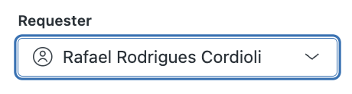

Escalations from Other TA Employees
When a TA employee emails us directly about a property:
- Acknowledge: Reply to the employee thanking them. State that we will continue the conversation with the owner directly. (Do not provide further case details).
- Search: Check Zendesk for existing conversations with that owner.
- New Ticket: If no existing thread exists, create a new ticket to the owner.
- Document: Quote the original employee inquiry in your Internal Notes.
Sometimes colleagues from other departments register as Owners to help their customer, if a registered/verified owner is using the @tripadvisor.com domain, please do not reply to them but to the actual owner.
When analysts in the User Review Dashboard (URD) use the "Escalate to SF" button on the right, one of the following Zendesk tickets is created:
ZD Ticket Subject | Drop Down selected
Potential CI Investigation Lead | Create Investigation Case
General Escalation | Fraud – Escalated Review
Fraud Escalation – Red Badge Recommendation | For the Investigations Team
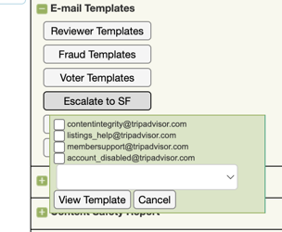

Handling Unclear Escalations
If a ticket is ambiguous or lacks sufficient information, follow these escalation paths to help improve inter-team quality:
- Unclear CS Tickets: Escalate to Tier 2. We will follow up with the CS team to improve their commenting quality.

